**Module 6: Multisensory Rooms**

**6C Sensory Rooms for Learners with Learning Difficulties**

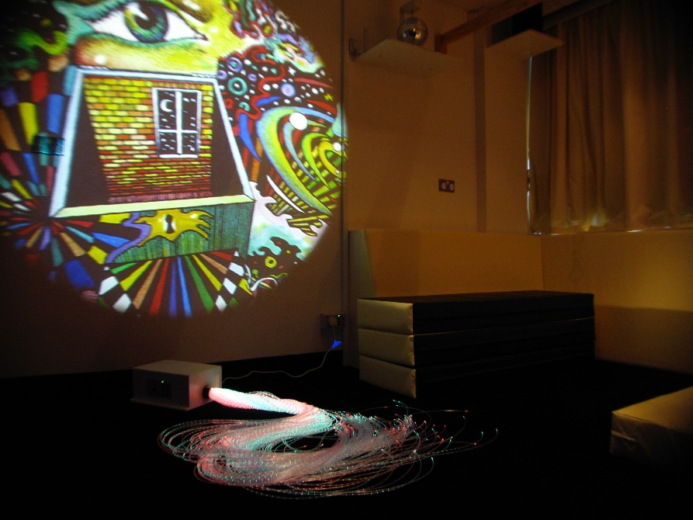

If learners have visual loss, choose equipment that will encourage using available vision and choose equipment in s similar way for those with a hearing condition.

Do this to create unique events to evoke a surprise and make compelling. Isolate a stimulus so you can isolate a skill e.g. a light for tracking.

The room itself can incorporate fixed equipment and could include fibre optics on floor, and bubble tubes with mirrors, for example. Items can be placed around the room so there is a choice of stimulus, but we recommend using no more than 2 at once.

When a room is more blank then this helps us isolate what the learner has responded to.